DIVISION BY 2
KS1 – 2001 Paper
1.
19

2.
14

KS1 – 2002 Paper
3.
KS1 – 2009 Paper 1
4.
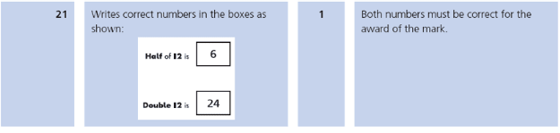
KS1 – 2016 Paper - Arithmetic
5.
KS1 – 2016 Paper - Arithmetic (Second)
6.
KS1 – 2017 Paper – Arithmetic
7.
KS1 – 2018 Paper – Arithmetic
8.
KS1 – 2019 Paper – Arithmetic
9.

